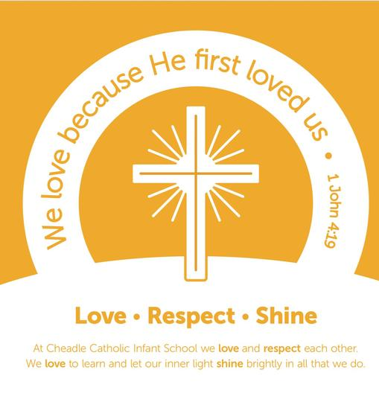

Computing Rationale 2024-25

Intent

At Cheadle Catholic Infants we believe that every child should have the right to a curriculum that champions excellence; supporting pupils in achieving to the very best of their abilities. We understand the immense value technology plays not only in supporting the computing and whole school curriculum but overall, in the day-to-day life of our school. We believe that technology can provide: enhanced collaborative learning opportunities; better engagement of pupils; easier access to rich content; support understanding of new concepts and can support the needs of all our pupils.

We aim to

* Provide an exciting, rich, relevant and challenging computing curriculum for all pupils which will be delivered in a designated lesson for computing.
* Teach pupils to become responsible, respectful and competent users of data, information and communication technology.
* Provide technology solutions for forging better home and school links.
* Enthuse and equip children with the capability to use technology throughout their lives.
* Teach pupils to understand the importance of legislation regarding how information is used, stored, created, retrieved, shared and manipulated.
* Utilise computational thinking beyond the computing curriculum.
* Give children access to a variety of high quality hardware, software and unplugged resources.
* Equip pupils with skills, strategies and knowledge that will enable them to reap the benefits of the online world, whilst being able to minimise risk to themselves or others.
* Use technology imaginatively and creatively to inspire and engage all pupils in lessons across the whole curriculum.
* Instil critical thinking, reflective learning and a ‘can do’ attitude for all our pupils, particularly when engaging with technology and its associated resources

Implementation

Nursery

During the Autumn term in Nursery children are introduced to a range of different technology through role play. Children have a chance to explore a range of everyday technology and how it works e.g. phones, cameras, and computers through their play. During the second part of the Autumn term the children are introduced to 2count. They go on a hunt in the school grounds to collect a range of Autumn leaves. They then explore ways of sorting the leaves e.g. size, colour or shape. They then use the 2count software to show the amount of each type and colour of leaves they found.

At the start of the spring term, children are introduced to the concept of computational thinking. They explore making a sequence of events using familiar stories. Children will sequence pictures from the story in the correct order. They will look at what happens if we put the main events from the story in the wrong order? Does the story still make sense? In the second half of the Spring term the children learn about simple instructions (algorithms) through a range of unplugged activities.

At the start of the Summer term, children will be introduced to the 2paint programme. They will create a picture using the tools to add and change effects on their picture.

During the 2nd half of the Summer term, the children will be given the opportunity to explore a range of programmable toys. Children will investigate how the toys work and what do they notice about the toys and how they work.

Reception

During the Autumn term in Reception children are introduced to the ipads. Children are given time to explore age appropriate apps. Children are taught how to care for the ipads. Children are taught how to turn the ipads on and how to open and close apps. During the second part of the Autumn term children are introduced to the 2paint program on the computers. Children learn how to use the tools to create their own pictures and add effects to their images. They are also taught how to type to add labels or captions to their pictures.

At the start of the spring term, children are introduced to taking photographs using the ipads. They use the ipads to take photographs in the local environment. Children learn how to take a good photograph and how to view it once they have taken it. They then work with a partner to take photos of each other as a superhero. They then add voice recording to their photo . In the second half of the Spring term the children are introduced to Simple City where they learn how to play simple games and how they work. They will explore that different actions happen when we click certain objects.

At the start of the Summer term, children will be introduced to algorithms through a range of unplugged activities. Children will explore that an algorithm is a set of instructions that if followed correctly will give a desired outcome.

During the 2nd half of the Summer term, the children will be given the opportunity to explore the Beebots. They will learn how to enter an instruction into the Beebot to make it move. They will also learn the language of forward, backwards, left and right. Children will explore entering a few commands to make the Beebot move along a grid.

Year 1

In the Autumn term of Year 1, children begin by exploring Purple Mash. They learn how to log in using their passwords and how to access different areas within Purple Mash. They then look at online safety, where they learn the importance of keeping themselves safe online.

The final part of this term is spent looking at programming through the topics Maze Explorers and Beebots. Children learn to follow and create simple instructions on the computer and consider how the order of instructions affects the results. They will explore the functionality of the direction keys and learn how to debug a set of simple instructions.

At the start of the Spring term children will learn how to create their own E-books using 2Create a Story. They will learn how to add animation, sound and voice recordings to their stories. They will also learn to copy and paste images into their E-books. In the second half of the Spring term children will learn how to Code in Purple Mash. They will plan and make their own computer program. During this topic they will begin to understand what instructions are and predict what might happen when they are followed. They will use code to make a computer program.

At the start of the Summer term in Year 1, children will learn how to create pictograms. They then focus on the topic of grouping and sorting. They learn to sort items using a range of criteria.

The final part of the Year 1 Summer term, children will learn about technology beyond school. They will explore the areas of the local community and find out where technology is used and its use in these areas. They will think about how different types of technology can make our lives easier day to day.

Year 2

In the Autumn term of Year 2, children will recap their knowledge of using Purple Mash independently. They will log on and navigate their way around Purple Mash, saving and retrieving work. The children will then extend on their prior knowledge of coding by creating their own computer program using algorithms. They will design an algorithm that follows a timed sequence and they will understand and debug simple programs. During the second part of this term the children will look at online safety and how we can search safely using search engines. They will also learn about communicating online using email and how we should talk to others online. They will also learn how information put online leaves a digital footprint.

At the start of the Spring term children build on their data handling skills through a topic on Questioning. They will learn about data handling tools that can give more information that pictograms. They will use a binary tree database (2Question) to answer yes and no questions.

During Spring 2 children will learn the functions of the 2Paint a Picture tool. They will learn about and recreate the Impressionist style of art (Monet, Degas, Renoir). They will recreate Pointillist art and look at the work of pointillist artists such as Seurat. They will then learn about the work of Piet Mondrian and recreate the style using the lines template. They will finish the term by exploring surrealism and eCollage.

At the start of the Summer term the children become musicians. They learn to make music digitally using 2Sequence to explore, edit and combine sounds. They will explore how music can be used to show feelings and they will make music which depicts feelings. They will finish the topic by recording and uploading environmental sounds to create tunes. Children will then focus on presenting ideas. They will explore how a story can be presented in a range of ways. They will then create their own quiz about a story or class topic. They will create a non-fiction fact file and present it to the class.

The final topic in Year 2 computing will focus on extending their prior knowledge of Spreadsheets. The children will use a range of tools within the 2Calculate program to make a counting machine. They will learn how to use the totalling tools within 2Calculate and will use a spreadsheet for money calculations.

Progress and Assessment

Formative assessment is undertaken each session in computing and pupils are encouraged to be involved in that process.

Teachers keep accurate records of pupil attainment by completing the skills assessment sheet each half term.

Children are encouraged to self, peer and group assess work in a positive way using online collaborative tools such as noticeboards and shared class folders in Purple Mash.

Through using the progression of skills documents teachers can evaluate progress.

Impact

Our pupils enjoy a range of computing activities. They build skills in using a variety of computing equipment and software. They are able to use their knowledge and skills to think critically and creatively.

The impact of the curriculum (how much computational knowledge and skills they have gained and remembered over time) will be reviewed throughout the year through lesson observations, class ‘Computing Books’, Pupils folders on Purple Mash and ‘Pupil Voice’ activities.

Signed: J E Kemal Date: September 2023