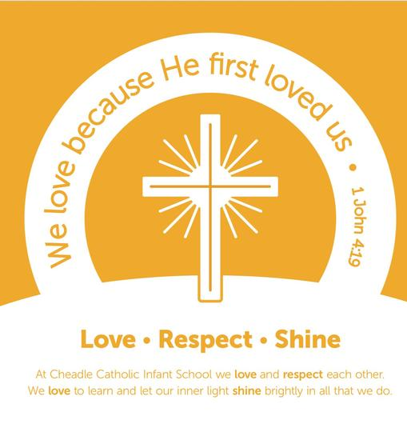

**Music Rationale**

At Cheadle Catholic Infant School music is a central part to our school community and therefore reflects in many areas of our daily lives. Every pupil within our school has access to participate in engaging and stimulating musical learning every week, providing them with building blocks to succeed and develop their skills and knowledge throughout EYFS, Key Stage one and beyond. Music is a unique way of communicating that can inspire and motivate children. It is a vehicle for personal expression and it can play an important part in the personal development of people.

The education of music is integral to our whole school curriculum and therefore we ensure that:

* Every child takes part in a whole class curriculum music lesson every week, which is linked to our skills based progression framework
* Year 2 pupils are encouraged to take part in school choir weekly
* Specialist teacher is employed to lead and plan the music lessons.
* Music coordinator and staff participate in professional development opportunities and take an active role in weekly curriculum music lessons.
* Pupils have opportunities to perform and share their progress to parents and carers
* A range of genres of music are played throughout the day in the hall, giving pupils the extended opportunities to develop their listening skills
* Pupils have access to a range of instruments during their music lessons.

**Intent and Impact**

**Intent**

Every music lesson has singing and song at the centre of the learning. Lessons are planned carefully, with song choices matching the pupils’ ages, abilities and interests. A culture of whole-school singing and deep listening are embedded via weekly curriculum music lessons.

At Cheadle Catholic Infant school, we are focused on developing children’s understanding of music by providing children with the skills via well planned and taught core musical activities which in turn will make our children composers, performers and improvisors. They can respond critically and make relevant observations of a range of musical genres, cultures and traditions.

* Every pupil from EYFS to Year 2 has a weekly whole class curriculum music lesson which is delivered by a specialist primary music teacher.
* Cross curricular links where appropriate are made to further support learning and the whole school curriculum.
* A carefully developed progression framework is used to ensure children make progress within each lesson, with clear, measurable learning objectives for every year group and are linked to assessment via specific descriptors for each area of attainment.
* There is a focus upon pupil response, reflection and appraisal in developing their own musical ideas.
* Medium term music planning for each year group supports an end of half term informal ‘class performance’, providing a chance for pupil appraisal
* Informed and skilled pedagogy which includes differentiated and pupil-led musical activities ensures appropriate levels of challenge and expectations for all pupils to make progress.
* Music Video/IT play an important role within the assessment process of music.
* Termly assessments are completed and used to aid future planning
* Pupils are encouraged to respond and reflect within lessons, developing their appraisal techniques and own musical knowledge.
* Formative and summative assessment is contained within the planning and therefore the musical attainment is evidenced via the range of learning activities in playing, singing, performing, composing and listening.
* Evidence of the progress made across the year is shown through half termly videos of individual pupils and class ‘performances’.

**Impact**

Pupils within our school enjoy their musical lessons, they have experience with playing tuned and untuned percussion and are engaged with different genres of music, they are keen to compose and perform, reflecting and evaluating upon music heard and learnt. The interest of pupils is shown through attendance at extra- curricular music sessions, positive pupil feedback via music ambassadors and a number of performance opportunities. The impact of the curriculum will be reviewed throughout the year, via lesson observations, class ‘Music floor books’ and ‘pupil voice’.

**Pupil Progress and Attainment**

Progress and attainment is assessed half termly in order to ensure that:

* Identification of most talented young musicians, who can then be appropriately signposted to further opportunities.
* School leaders, music coordinator and music teacher continually aim to improve, innovate and monitor the provision.
* Any gaps in learning can be identified and rectified with adaptations to planning.
* Musical activities identify and target specific needs for every pupil and broaden their musical skills.
* The assessment focuses are linked to the progression grid and planning and are based on pupil’s ability to take on creative risks and apply skills learned with confidence.
* Pupils who are identified as ‘*exceeding’* demonstrate confidence and leadership along with high levels of skill in their musical responses in lessons.