Week Beginning: 15th September 2025
This week in Nursery we will be learning…

  Religious Education | - Learning our school prayer  - Making the Sign of the Cross
Communication & Language &    Literacy | - Exploring our feelings through ‘The Colour Monster’ story.  - Circle games- turn taking, getting to know each other, name games.  - Sharing stories about starting Nursery.  - Mark making
Mathematics & Physical development  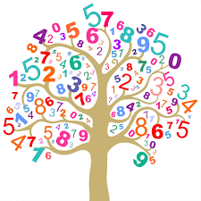 | - Smile for a mile!  - Squiggle while you wriggle!  - Bingo.  - Cutting skills.  - Number songs to 5.
Other Areas  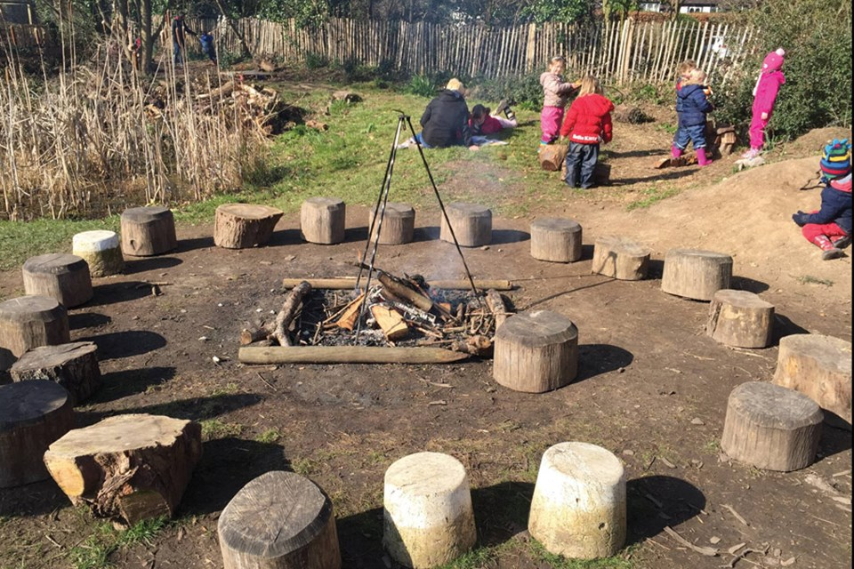 | - Assembly with Mrs Glynn.  - School Library visit.  - Forest School

