Week Beginning: 22nd September 2025
This week in Nursery we will be learning…

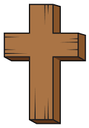  Religious Education | - We will introduce the children to our ‘Golden box’. What do we think is inside? Inside the box will be The Bible. We will discuss with the children that The Bible is a special book.  - What is special to us? Children will draw a picture.  - We will make loose part crosses.  - We will make our own cross using crafts.  - We will practice making the sign of the cross in the mirror.
Communication & Language &  Literacy  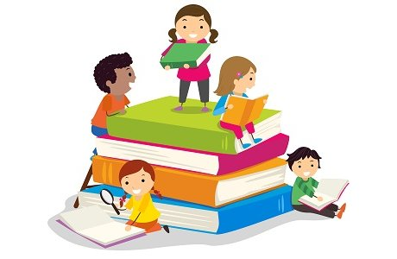 | - Continuing to explore our feelings through ‘The Colour Monster’ story.  - Circle games- turn taking, getting to know each other, name games.  - Mark making  - Going on a listening walk around school
Mathematics & Physical development  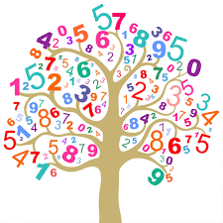 | - Smile for a mile!  - Squiggle while you wriggle!  - Dough Disco  - Cutting skills.  - Number songs to 5.
Other Areas  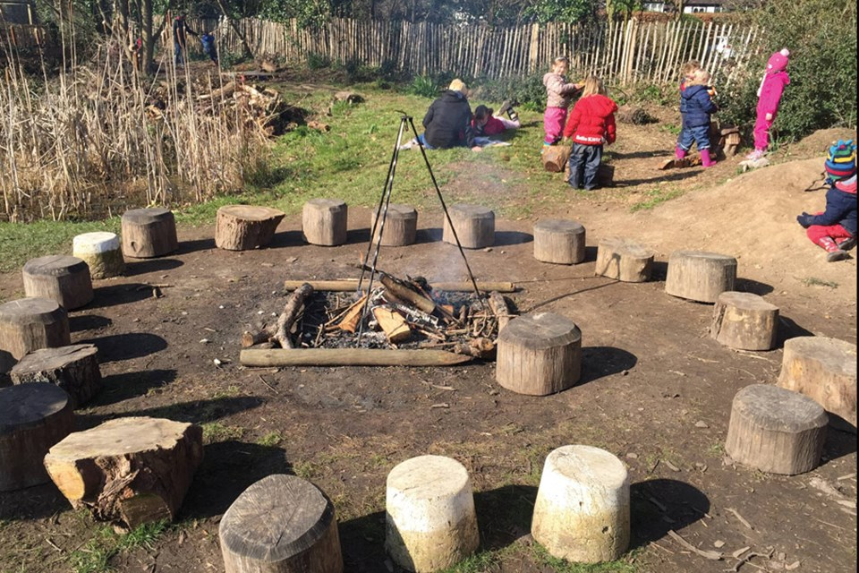 | - Assembly with Mrs Glynn.  - School Library visit.  - Forest School  - Music with Mrs Marshall

