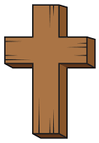  Religious Education | - Inside our golden box will be a picture of the world. Children will explore all of the wonderful things God made for his world.  - We will make God’s world with our small world figures.  - We will create drawings of the sea and sky.  - We will explore light and dark using torches under black material.  - We will make sun. moon and star decorations.  - We will explore what plants and trees are growing in our outdoor area.
Communication & Language &  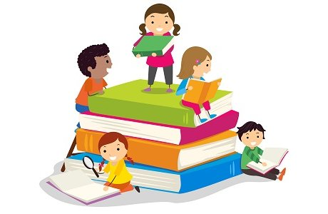  Literacy | - Exploring our feelings through ‘The Colour Monster’ story focusing on the red colour monster.  - Going on a listening walk around school  - Practice singing Twinkle Twinkle little star to perform at the poetry assembly.  - Circle games- turn taking, getting to know each other, name games.  - Mark making
Mathematics & Physical development  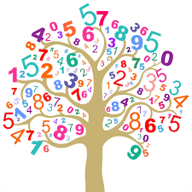 | - Maths of the day- making ABAB patterns using cones.  - Smile for a mile!  - Squiggle while you wriggle!  - Bingo.  - Cutting skills.  - Number songs to 5.
Other Areas  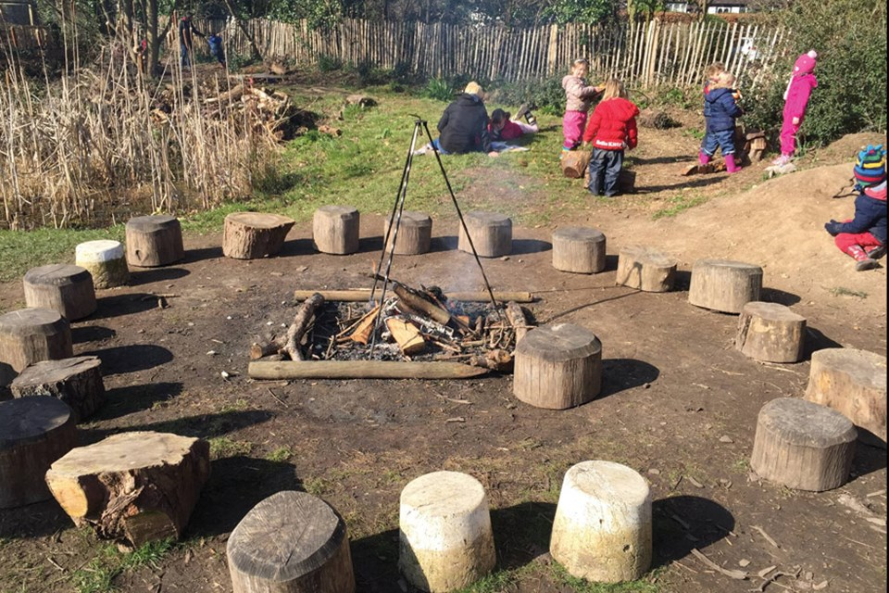 | - Assembly with Mrs Glynn.  - School Library visit.  - Forest School

