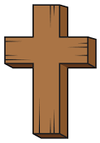  Religious Education | - Celebrating God’s world during the Harvest Festival  - Leaf and potato printing  - Farm Shop roleplay  - Scarecrow crafts
Communication & Language &  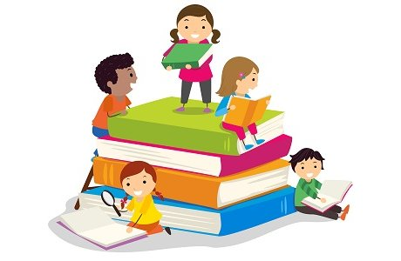  Literacy | - Exploring our feelings through ‘The Colour Monster’ story focusing on the grey colour monster.  - Sound Lotto- Animal noises  - Which sound? Identifying instrument sounds  - Mark making
Mathematics & Physical development  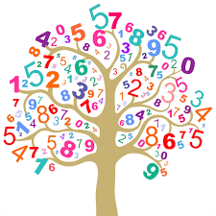 | - Maths of the day- making ABAB patterns using peg boards.  - Maths of the Day- Printing Numicon shapes with paint making ABAB patterns.  - Smile for a mile!  - Squiggle while you wriggle!  - Cutting skills.
Other Areas  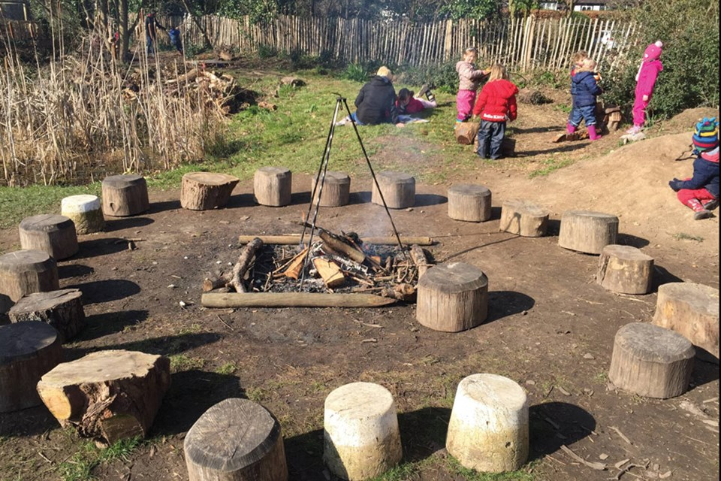 | - Assembly with Mrs Glynn.  - Forest School with Mrs Marshall  - Black History Month- Celebrate Mo Farah’s achievements  - World Mental Health Week- 5 ways to wellbeing.

