Week Beginning: 13th January 2025
This week in Nursery we will be learning…
Our Nursery Rhyme of the Week is Old MacDonald had a farm.
  Religious Education | - Thinking about how we can show our love to Jesus by doing something kind for someone else.  - Children will share some ideas of how they can show kindness to others. E.g. playing together, sharing toys etc
Communication & Language &    Literacy | - Singing Nursery rhymes.  - Hide and seek—Old MacDonald’s animals will be hidden. The teacher will sound out each one in turn. The children to make the noise of the animal that they think is missing.  - Can you find—objects will be hidden around the room and children will race each other in pairs to find the objects that has been said using fred talk e.g. can you find a h-a-t.
Mathematics & Physical development   | - Smile for a mile!  - Squiggle while you wriggle!  - Cutting Skills  - Number songs e.g. 5 current buns in a bakers shop, 5 little men in a flying saucer etc.  - Finding different ways to show 2.  - PE in the hall.
Other Areas  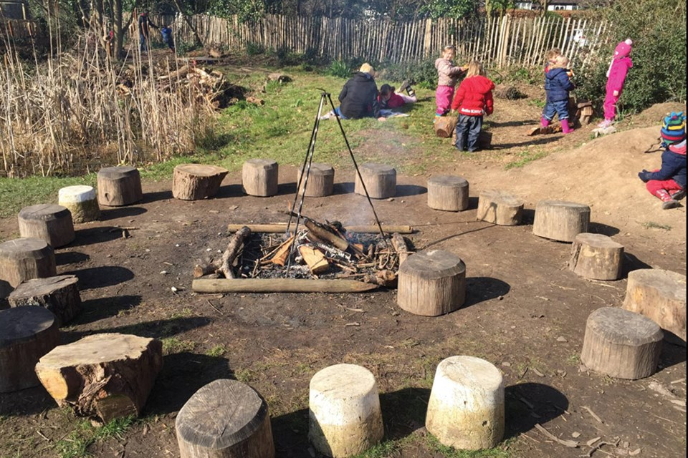 | - Assembly with Mrs Glynn.  - Music on Wednesday.  - Forest School on Friday.  - Talking about internet safety.

