Week Beginning: 28th October 2024
This week in Nursery we will be learning…
  Religious Education | - Looking at the Rosary for the month of Mary.  - Putting a prayer in our class prayer book.
Communication & Language &  Literacy Development   | - Sounds like—children pull something out of the magic bag. Say the initial sound for the object together e.g. p for pig. Everyone as a group thinks of something else that starts with that initial sound.  - Silly soup– make a spooky soup with items that rhyme. E.g. hat and cat, star and car etc.  - What is my name? - Each child has an instrument . They can make a sound with their instrument if their name begins with ‘s’ for example.  - Footprints will be on the carpet leading to the magic story box. Children will talk about and guess who they might belong to and what our new story may be.
Numeracy &  Physical Development   | - Simple number songs to 10.  - Smile for a mile!  - Squiggle while you wriggle.  - Dough disco.  - Children will work in teams to order their pumpkins from biggest/largest to smallest.  - Coloured water and pipettes for fine motor outdoors, children will use the pipettes to see how full they can get their container using a timer to challenge themselves.
Other Areas  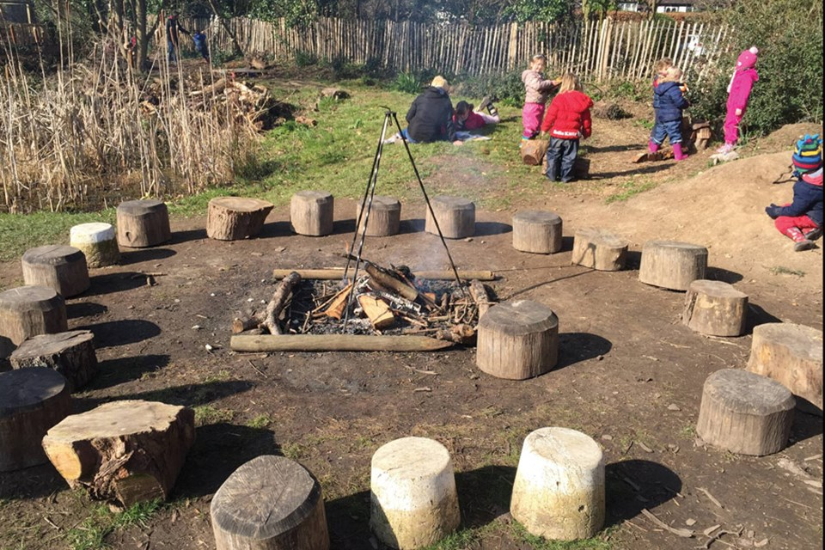 | - Outdoor play

