Week Beginning:11th November 2024

This week in Nursery we will be learning…
  Religious Education | - Annunciation  - Sharing our own good news.  - Acting out the angel Gabriel coming to tell Mary the good news.
Communication & Language &  Literacy Development   | - Children will practice making letter shapes from their name.  - Metal mike—Children will verbally blend CVC words using fred talk. They will feed their item to metal mike the robot.  - Silly soup—make soup with items that rhyme.  - I spy—hearing initial sounds. Go on a walk outside and play eye spy.
Numeracy &  Physical Development   | - Simple number songs to 10.  - Smile for a mile!  - Squiggle while you wriggle.  - Dough disco.  - Matching numbers to amounts within 5.
Other Areas  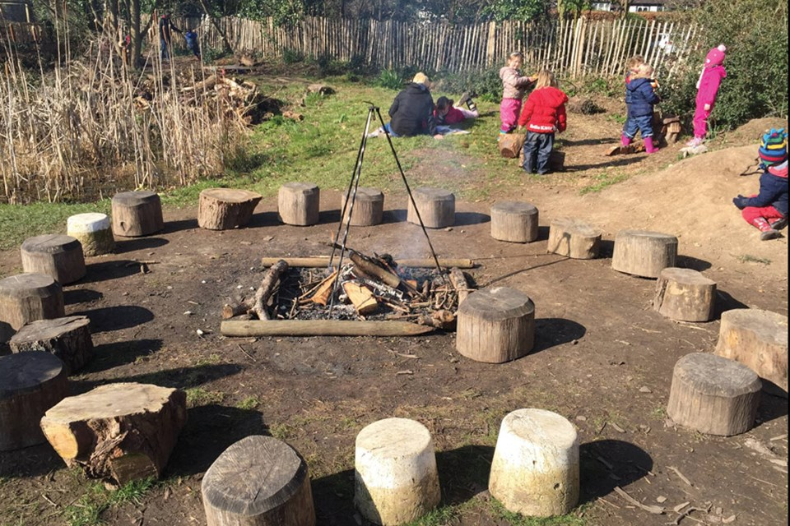 | - Outdoor play  - Forest school  - Talk about climate change and visit our school allotment.  - Talking about remembrance day and printing our own poppies.

