Week Beginning: 30th September 2024
This week in Nursery we will be learning…
  Religious Education | - Little Way week, thinking of one thing we can do each day to make a difference.  - Looking at the Rosary for the month of Mary.
Communication & Language &  Literacy Development   | - Circle Times – getting to know one another.  - We will have our colour monster characters. The children will re-cap what each one means. We will then focus on the grey colour monster. Each child will have turn at holding the colour monster to share in the circle what they are scared of.  - Naming instruments for Musical Statues —children will practice naming instruments and then follow instructions to start and stop on command.  - Find the bear-Children need to guide a friend by making their voices louder if they get close to the bear and quieter if they get further away.
Numeracy &  Physical Development   | - Simple number songs to 10.  - Smile for a mile!  - Maths of the Day –children given two colours of cones to make ABABAB patterns e.g. blue, red, blue, red.
Other Areas  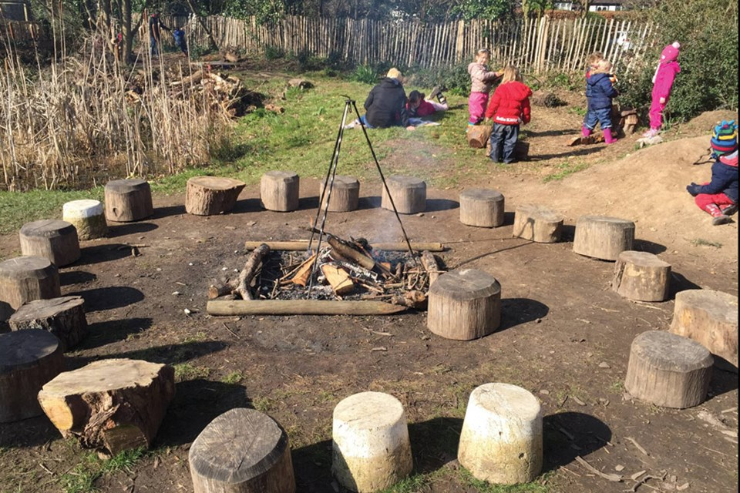 | - Outdoor play  - Learning about our classroom.  - Learning about our Golden Rules.  - Music with Mrs Marshall on Wednesday.  - Forest School on Friday.  - Talking about Mo Farrah for Black History Month.

