Week Beginning:25th November 2024

This week in Nursery we will be learning…
  Religious Education | - Talking about Advent.
Communication & Language &  Literacy Development   | - Tales Toolkit, on big paper the children will work together to record the character, setting, problem and solution in our Gruffalo story.  - Sound lotto– Children will hear different household sounds e.g. a shower or kettle and then will guess what the sound was.  - Drawing shapes in the mark making area.
Numeracy &  Physical Development   | - Simple number songs to 10.  - Smile for a mile!  - Squiggle while you wriggle.  - Dough disco.  - Fundamental movement skills with Mrs Wall on Thursday.  - Building towers with the large building blocks outside. Children will work in pairs to be the fastest to build a tower of a given number.  - There will be a 1 min timer. The children will be in pairs and will build a tower each. They can then compare who's is the tallest or shortest.
Other Areas  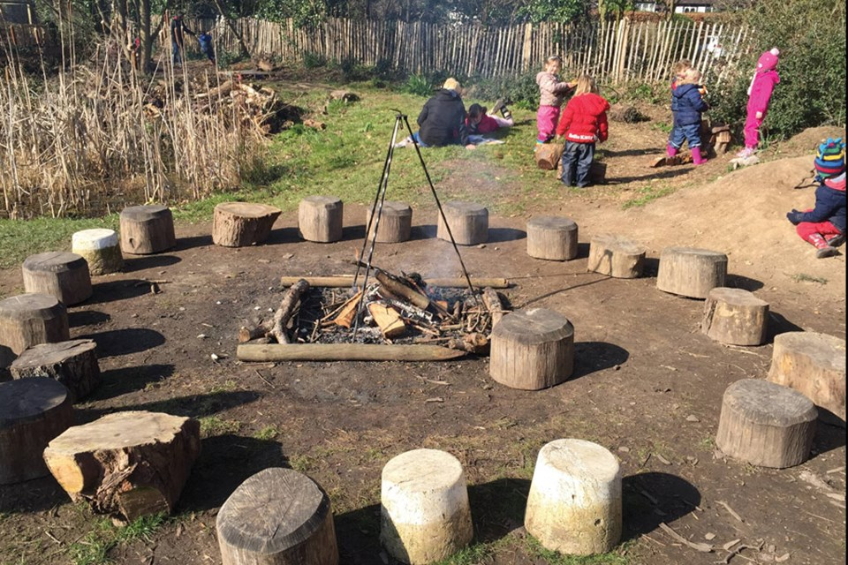 | - Outdoor play  - Designing a habitat for a Gruffalo.  - Singing songs for our Nativity play!

