Week Beginning:2nd December 2024

This week in Nursery we will be learning…
  Religious Education | - Talking about Advent.  - Practicing our nativity.
Communication & Language &  Literacy Development   | - Tales Toolkit, children will independently record the character, setting, problem and solution in our Gruffalo story.  - Writing our names in Christmas cards.  - Drawing shapes in the mark making area.
Numeracy &  Physical Development   | - Simple number songs to 10.  - Smile for a mile!  - Squiggle while you wriggle.  - Dough disco.  - Fundamental movement skills with Mrs Wall on Thursday.  - Building towers with the large building blocks outside. Children will compare their towers using the language of taller and shorter.  - Children will have different lengths or ribbon to use the language of longer and shorter.
Other Areas  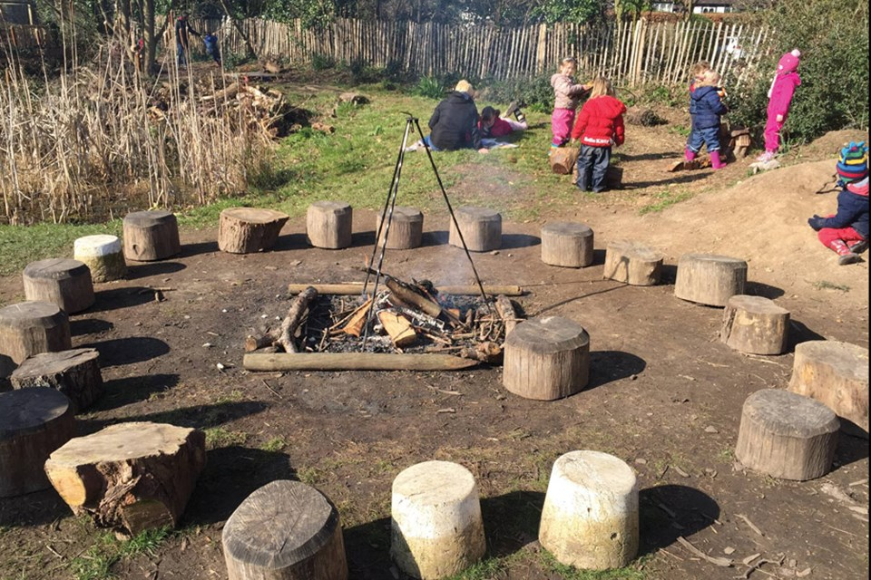 | - Outdoor play  - Making a habitat for a Gruffalo.  - Singing songs for our Nativity play!  - Making Christmas cards.

