Week Beginning:9th December 2024

This week in Nursery we will be learning…
  Religious Education | - Talking about Advent.  - Performing our nativity.
Communication & Language &  Literacy Development   | - Metal Mike, children to blend the sounds together of the cvc items to feed to the robot.  - Silly soup: Children to find a rhyming pair to put into the Christmas soup.  - Letter to Santa: Children to draw a picture of what they would like for Christmas and see if they can say the initial sound for their present eg. Roller skates ‘r’.
Numeracy &  Physical Development   | - Simple number songs to 10.  - Smile for a mile!  - Squiggle while you wriggle.  - Dough disco.  - Fundamental movement skills with Mrs Wall on Thursday.  - Repeated pattern on stockings.  - Children will have different lengths or ribbon to use the language of longer and shorter.
Other Areas  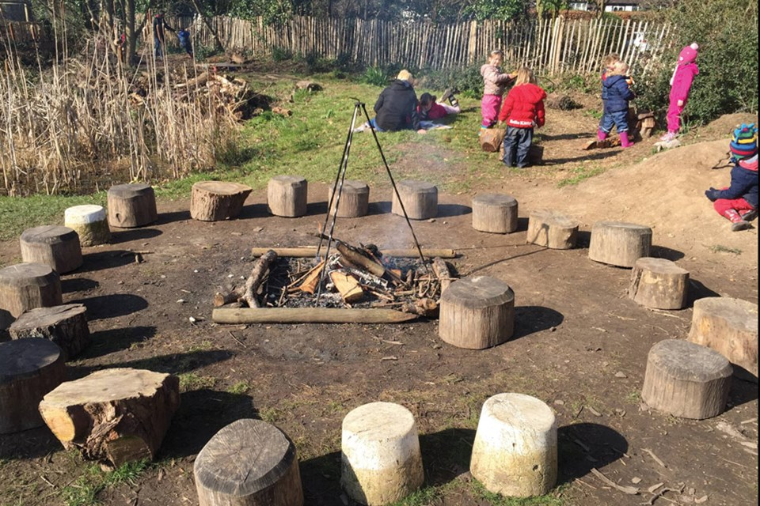 | - Outdoor play  - Singing songs for our Nativity play!  - Making Christmas cards.

