Week Beginning: 6th January 2025
This week in Nursery we will be learning…
Our Nursery Rhyme of the Week is Wheels on The Bus
  Religious Education | - Remembering the story of the nativity.  - Sharing what we did over Christmas.
Communication & Language &    Literacy | - Singing Nursery rhymes.  - Rhyming Book— children touch their head when they hear two words that rhyme.  - Cross the River—children can jump over the river when they hear their cvc word spoken e.g. jump over the river if you have the p-i-g  - Silly soup—making soup with rhyming words.
Mathematics & Physical development   | - Smile for a mile!  - Squiggle while you wriggle!  - Cutting Skills  - MOTD—bean bag throwing into the hoop. 3 bean bags in pairs. One child throws, one child counts how many goes in.  - Number songs e.g. 5 current buns in a bakers shop, 5 little men in a flying saucer etc.  - Finding different ways to show 1.  - Bus Shapes. The children will have a range of shapes to make a bus with. They are going to be cutting out these shapes.  - PE in the hall.
Other Areas  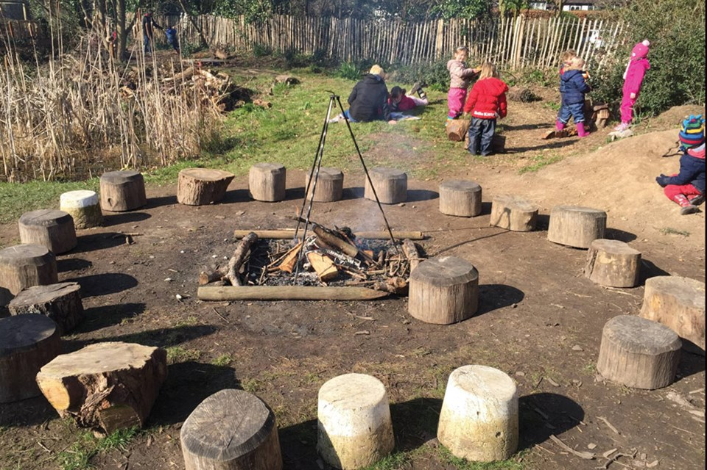 | - Assembly with Mrs Glynn.  - Music on Wednesday.

