Week Beginning: 27th January 2025
This week in Nursery we will be learning…
Our Nursery Rhyme of the Week is Incy Wincy Spider
  Religious Education | - Hearing the story of Jesus feeding the 5,000.
Communication & Language &    Literacy | - Singing Nursery rhymes.  - Treasure Hunt—. Children work in pairs to find pairs that rhyme that are hidden around the room.  - Hear the beat—The children will clap and stamp a beat along with a drum.  - Mark making symbols for lunar new year.
Mathematics & Physical development   | - Smile for a mile!  - Squiggle while you wriggle!  - Cutting Skills, making our own spider.  - Number songs e.g. 5 current buns in a bakers shop, 5 little men in a flying saucer etc.  - Using a five frame to show the amounts one, two and three.  - PE in the hall.  - Outside there will be hoops with the numbers 1, 2 or 3 in them. The children will have to put the correct amount of beanbags in each hoop.  - Rescuing the spiders from the web using tweezers.
Other Areas  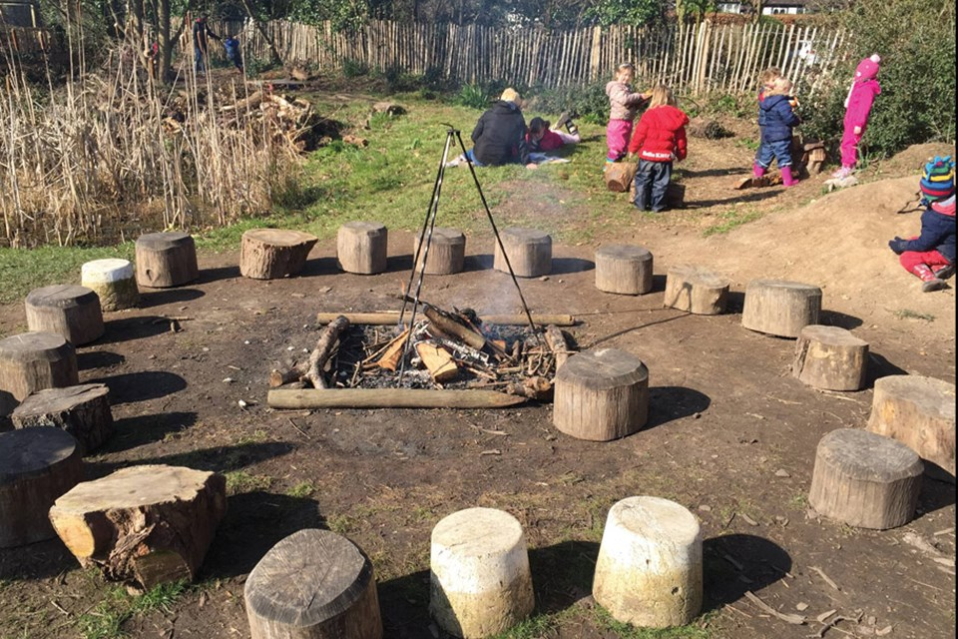 | - Assembly with Mrs Glynn.  - Music on Wednesday.  - Forest School on Friday.  - Lunar New Year celebrations on Friday.

