Week Beginning: 3rd February 2025
This week in Nursery we will be learning…
Our Nursery Rhyme of the Week is Twinkle Twinkle

  Religious Education | - Visit from Bishop Mark.
Communication & Language &    Literacy | - Singing Nursery rhymes.  - Guessing what animal is hiding in the box e.g. it lives on the farm and begins with ‘p’. Is it a…….. penguin, pig, panda etc.  - Mark making stars.  - Clapping how many syllables are in each animals name.
Mathematics & Physical development  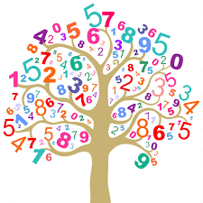 | - Smile for a mile!  - Squiggle while you wriggle!  - Number songs e.g. 5 current buns in a bakers shop, 5 little men in a flying saucer etc.  - PE in the hall.  - Using triangle shapes to make stars.  - Mark making to show 1, 2 and 3.  - Match stars to number 1,2,3.
Other Areas  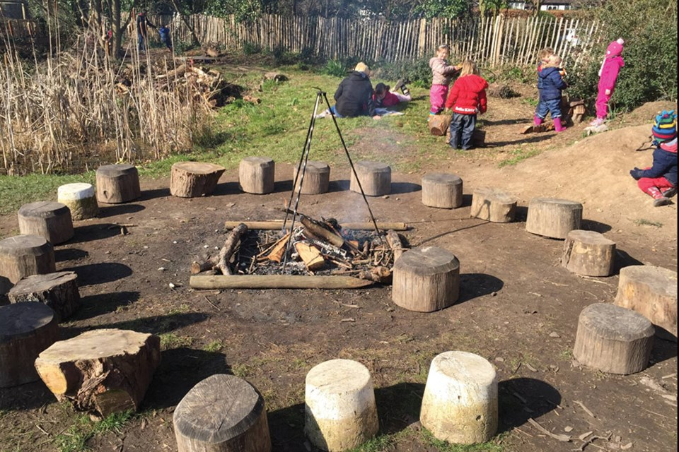 | - Assembly with Mrs Glynn.  - Music on Wednesday.  - Library on Friday.  - Mental Health Awareness Week.

