Week Beginning: 10th February 2025
This week in Nursery we will be learning…
Our Nursery Rhyme of the Week is Humpty Dumpty

  Religious Education | - Hearing the Bible story of how Simon Peter, James and John were compelled to follow Jesus after witnessing a miraculous catch of fish.  - Reminding the children that they too are invited to follow Jesus and become part of God’s family.
Communication & Language &    Literacy | - Singing Nursery rhymes.  - Metal Mike —children will hear a CVC word segmented they are to blend the sounds and feed the item to metal mike.  - River jumping —Children stand on one side of the river and can jump out to safety when they hear their CVC word being segmented.  - Squiggle while you wriggle.
Mathematics & Physical development   | - Smile for a mile!  - Squiggle while you wriggle!  - Number songs e.g. 5 current buns in a bakers shop, 5 little men in a flying saucer etc.  - PE in the hall.  - Mark making to show 1, 2 and 3.  - Cutting out eggs.
Other Areas  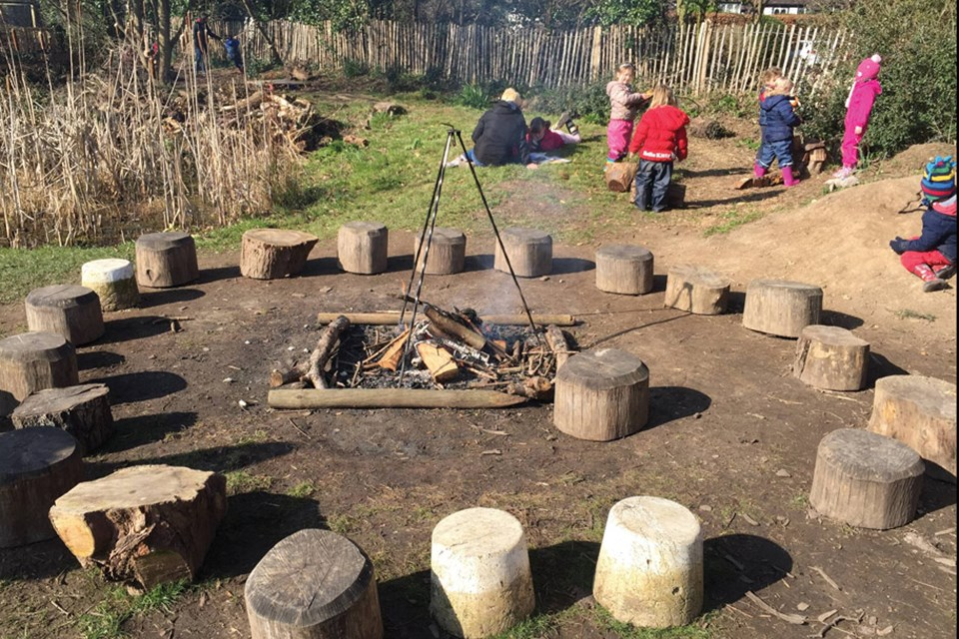 | - Assembly with Mrs Glynn.  - Music on Wednesday.  - Safer Internet Day.  - Forest School on Friday.  - Decorating Humpty Dumpty’s egg.

