Week Beginning: 24th February 2025
This week in Nursery we will be learning…
Our focus Traditional Tale is The Three Little Pigs

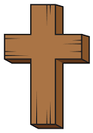  Religious Education | - Talking about what a bible is and why it is special.  - Looking at symbols of Jesus e.g. a candle.
Communication & Language &    Literacy | - Talking about the materials that the three little pigs used for building and why they were good/not good. Children will draw their own house and describe what they would use to build it and why.  - Children will blend CVC items to feed the puppet.  - Playing eye spy to know initial sounds.  - Name Writing.  - Re-telling the story of The Three Little Pigs.
Mathematics & Physical development  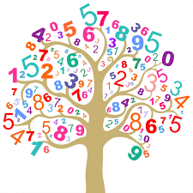 | - Smile for a mile!  - Squiggle while you wriggle!  - Number songs e.g. 5 current buns in a bakers shop, 5 little men in a flying saucer etc.  - PE in the hall. This half term we are going to be doing gymnastics.  - Ordering a range of items from strongest to weakest for building the three little pigs house.
Other Areas  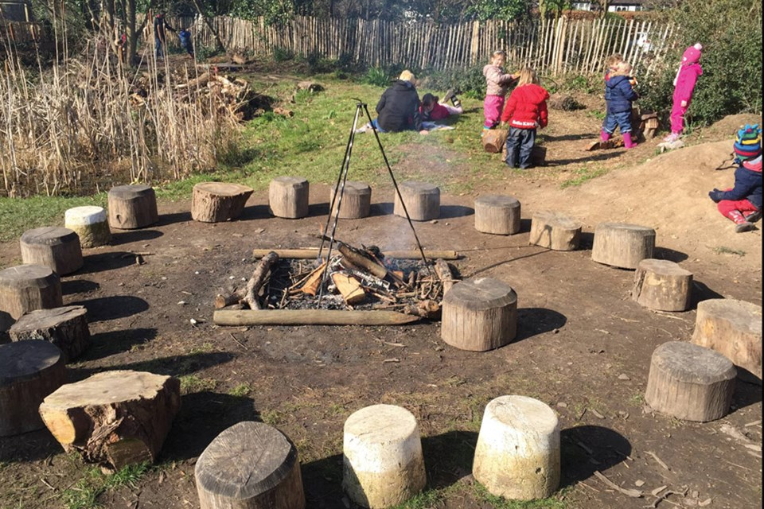 | - Assembly with Mrs Glynn.  - Music on Wednesday.  - Library on Friday.

