Week Beginning: 3rd March 2025
This week in Nursery we will be learning…
Our focus Traditional Tale is Little Red Riding Hood

  Religious Education | - Prayer and Liturgy time.  - Talking about making a promise for Lent.
Communication & Language &    Literacy | - Children will draw their favourite story/character and talk about why they like it.  - Eye spy activity cards to hear initial sounds in words.  - Making silly soup, children to put two items in the soup that rhyme.  - Reading Café in the hall on Wednesday.  - Mystery Reader, someone different to come in and read a story.  - Masked Reader, children to guess who is reading the story behind the mask.
Mathematics & Physical development   | - Smile for a mile!  - Squiggle while you wriggle!  - Number songs e.g. 5 current buns in a bakers shop, 5 little men in a flying saucer etc.  - PE in the hall. This half term we are going to be doing gymnastics.  - Playing what’s the time Mr Wolf  - Children will find different ways to show 4.  - Children to show ‘finger numbers’ up to 5.
Other Areas  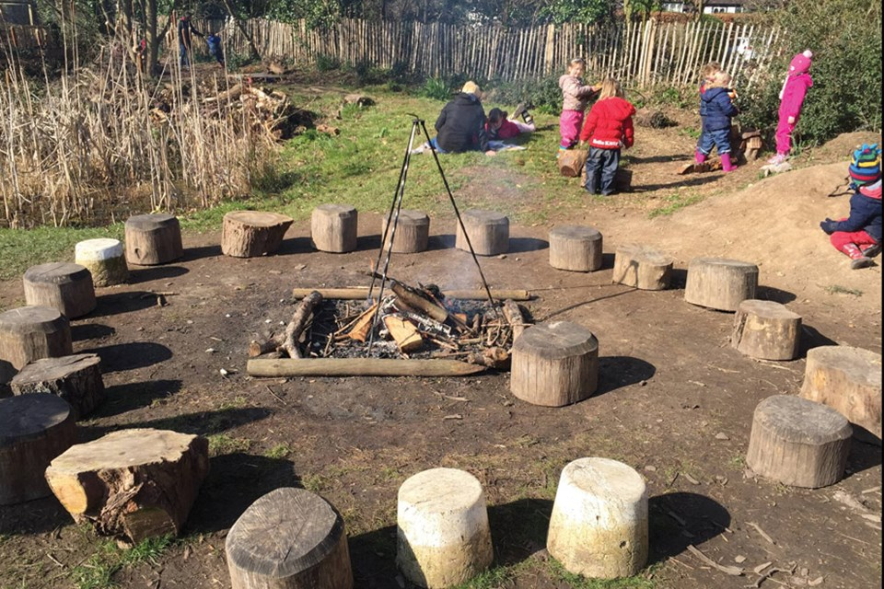 | - Assembly with Mrs Glynn.  - Music on Wednesday.  - WORLD BOOK DAY ON THURSDAY!  - Forest School on Friday.

