Week Beginning: 10th March 2025
This week in Nursery we will be learning…
Our focus Traditional Tale is Jack and the Beanstalk

  Religious Education | - Prayer and Liturgy time.  - Talking about making a promise for Lent.
Communication & Language &    Literacy | - Sequencing the story of Jack and the Beanstalk.  - Silly soup, children to put two items in the soup that rhyme.  - Eye Spy, children to play eye spy to identify initial sounds in words using pictures to help them.
Mathematics & Physical development   | - Smile for a mile!  - Squiggle while you wriggle!  - Number songs e.g. 5 current buns in a bakers shop, 5 little men in a flying saucer etc.  - PE in the hall. This half term we are going to be doing gymnastics.  - Children to get a beanstalk (strip of green ribbon) and to measure it against different things outdoors to see if their beanstalk is longer e.g. than a brick or shorter e.g. than the house.  - Different ways to show four and five.
Other Areas  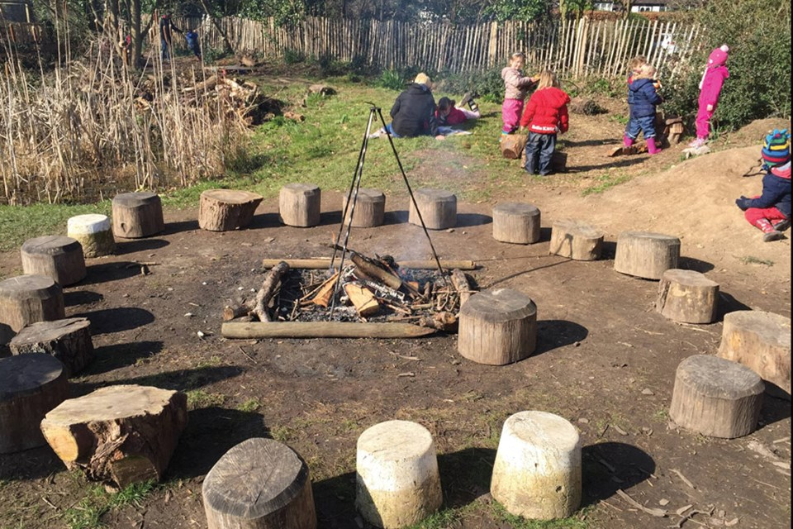 | - Assembly with Mrs Glynn.  - Music on Wednesday.  - Library on Friday.

