Week Beginning: 17th March 2025
This week in Nursery we will be learning…
Our focus Traditional Tale is Goldilocks and the Three Bears

  Religious Education | - Prayer and Liturgy time.  - Talking about Palm Sunday.
Communication & Language &    Literacy | - Sequencing the story of Goldilocks and the Three Bears.  - Find the instrument.– Children close their eyes and their friend plays an instrument, children have to identify where the sound came from by pointing and what instrument is being played.  - What’s in the sound box?—CVC items to orally blend and segment.  - Rhyming Book children will touch their heads when they hear a rhyming word.
Mathematics & Physical development  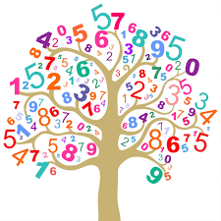 | - Smile for a mile!  - Squiggle while you wriggle!  - Number songs e.g. 5 current buns in a bakers shop, 5 little men in a flying saucer etc.  - PE in the hall. This half term we are going to be doing gymnastics.  - Outdoor mark making to show numbers with chalk e.g. lines, circles, tally, forming the number etc.  - Making Number bonds to 4.
Other Areas  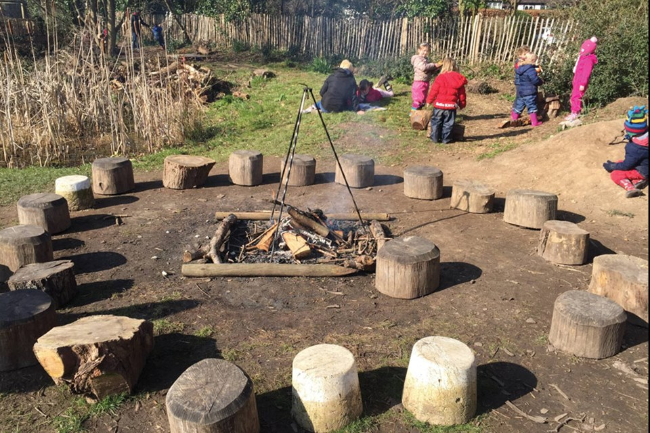 | - Assembly with Mrs Glynn.  - Music on Wednesday.  - Forest School on Friday.  - Making and weighing porridge.

