Week Beginning: 24th March 2025
This week in Nursery we will be learning…
Our focus Traditional Tale is Goldilocks and the Three Bears

  Religious Education | - Prayer and Liturgy time.  - Talking about the parable of the Good Samaritan.
Communication & Language &    Literacy | - Sequencing the story of the Gingerbread man.  - Feed the puppet CVC items to orally blend and segment.  - Rhyming Jump—Children have to jump in the hoop with the picture that rhymes with the word the teacher says.  - Name writing.
Mathematics & Physical development  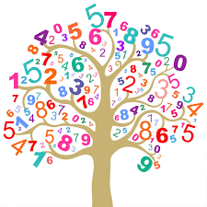 | - Smile for a mile!  - Squiggle while you wriggle!  - Number songs e.g. 5 current buns in a bakers shop, 5 little men in a flying saucer etc.  - PE in the hall. This half term we are going to be doing gymnastics.  - Playing bingo to recognise numbers 1 to 6.  - Number bonds to 4 and 5, the children will have multilink to show the different ways to see four and five.
Other Areas  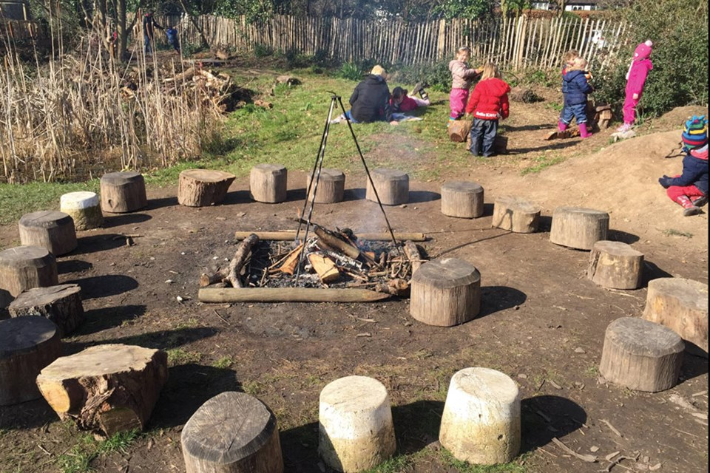 | - Assembly with Mrs Glynn.  - Music on Wednesday.  - Library on Friday.  - Making Mothers Day Cards.  - Plating seeds.

