Week Beginning: 31st March 2025
This week in Nursery we will be learning…
Our focus story is ‘That’s not my story.’

  Religious Education | - Prayer and Liturgy time.  - Talking about the parable of the Fig Tree.
Communication & Language &    Literacy | - Magic story box exploring ‘That’s not my story.’  - Sound hunt inside e.g. go and find something that begins with ’p’.  - Rhyming songs  - Battleships—Children to use their listening skills to build the tower how their friend describes. They then hold up their towers over the screen to see if they match the person who gave the instruction.  - Name writing.  - Making up our own fairy tales.
Mathematics & Physical development  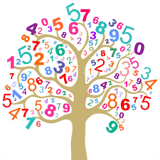 | - Smile for a mile!  - Squiggle while you wriggle!  - Number songs e.g. 5 current buns in a bakers shop, 5 little men in a flying saucer etc.  - PE in the hall. This half term we are going to be doing gymnastics.  - Playing bingo to recognise numbers 1 to 6.  - Dough disco.
Other Areas  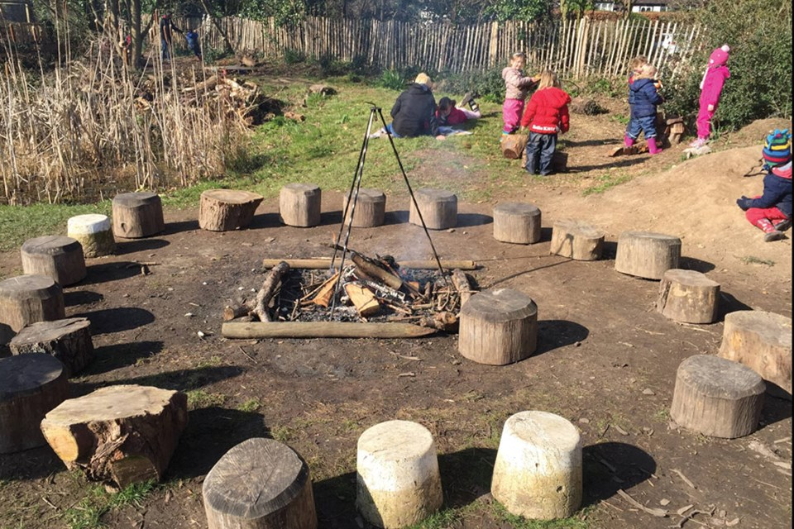 | - Assembly with Mrs Glynn.  - Music on Wednesday.  - Forest School on Friday.

