Week Beginning: 28th April 2025
This week in Nursery we will be learning…

  Religious Education | - Talking about our Easter celebrations.
Communication & Language &    Literacy | - Name Writing  - Metal mike— Children to blend together three sounds to make a word. This will relate to an object that they will then feed the robot. E.g. p-i-g.  - ‘m’ sound.  - Drawing what we did over the holidays.
Mathematics & Physical development   | - Smile for a mile!  - Squiggle while you wriggle!  - Dough disco.  - Number songs.  - Mark making to show numbers 1-5.  - Recognising numbers to 10.
Other Areas  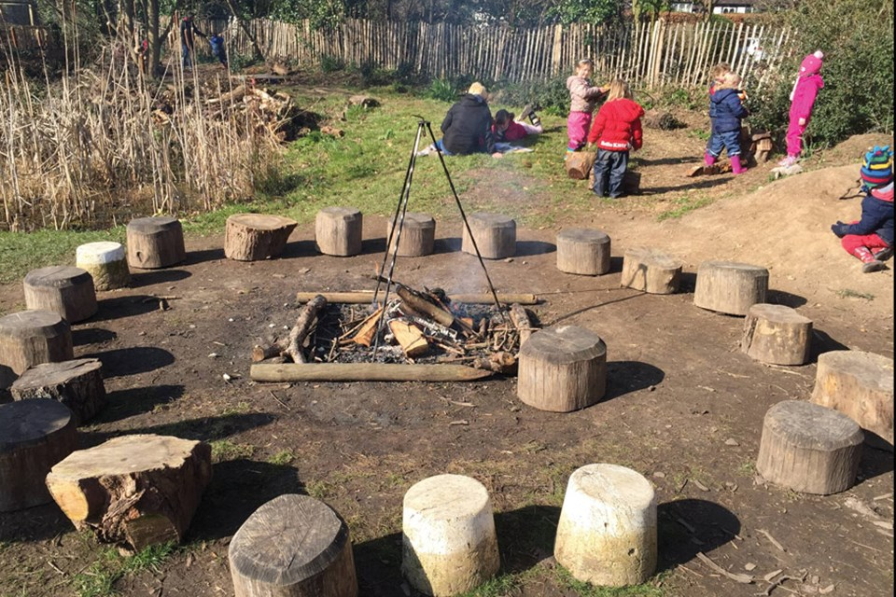 | - Assembly with Mrs Glynn.  - Music on Wednesday.  - Forest school on Friday.  - Walk around forest school to spot signs of spring.

