Week Beginning: 5th May 2025
This week in Nursery we will be learning…

  Religious Education | - Talking about the assentation into heaven.
Communication & Language &    Literacy | - Name Writing  - Metal mike— Children to blend together three sounds to make a word. This will relate to an object that they will then feed the robot. E.g. p-i-g.  - ‘m’ sound.  - Talking about different farm animals and naming baby farm animals.
Mathematics & Physical development   | - Smile for a mile!  - Squiggle while you wriggle!  - Dough disco.  - Number songs.  - Counting different actions to 10 e.g. 5 star jumps, 3 frog jumps etc.  - Recognising numbers to 10.
Other Areas  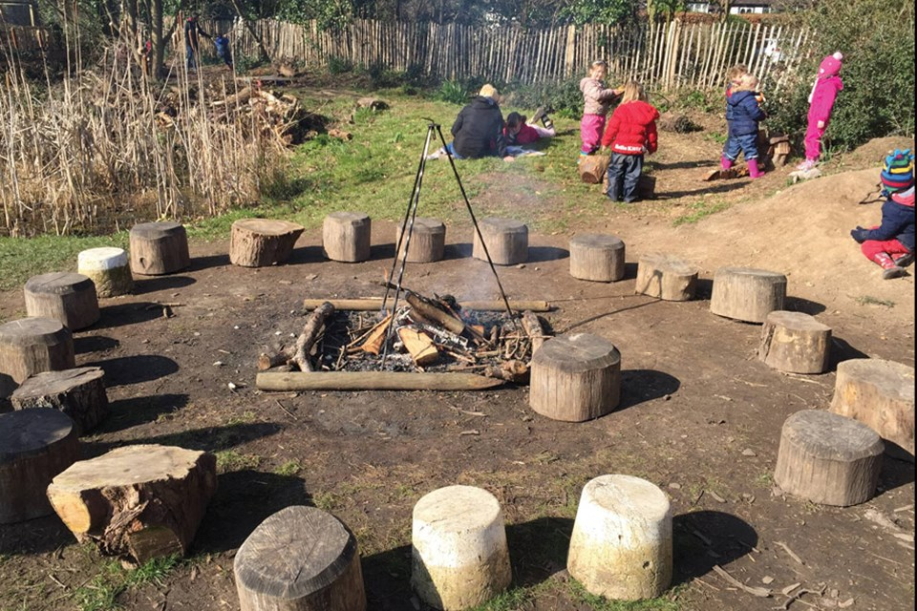 | - Assembly with Mrs Glynn.  - TRIP TO THE FARM ON WEDNESDAY!  - Library on Friday.  - VE Day celebrations on Thursday.

