Week Beginning: 20th May 2024
This week in Nursery we will be learning…

  Religious Education | - Talking about why May is a special month for Mary.  - Saying the hail Mary.
Communication & Language &    Literacy | - Name Writing  - Eye spy, recognising the initial sounds in words.  - ‘g’ sound.  - Re-telling the story of ‘Jaspers Beanstalk.’
Mathematics & Physical development   | - Smile for a mile!  - Squiggle while you wriggle!  - Finding the difference between how many animals they can see and the total number.  - Outdoors children will run around the outside of the hoops. When the teacher shouts stop they jump in a hoop. In the centre is a basket of balls. They put the correct number of balls in the hoop to match their numeral. Recognising numbers to 10.
Other Areas  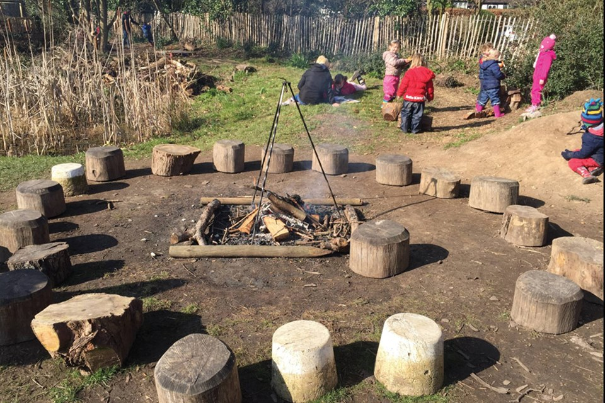 | - Assembly with Mrs Glynn.  - Music on Wednesday.  - Forest school on Tuesday and Friday.  - Looking at the lifecycle of a butterfly.  - Butterfly painting and printing.  - Observing the changes in our caterpillars.

