Week Beginning: 23rd June 2025
This week in Nursery we will be learning…

  Religious Education | - Talking about the Early church and what this was like.  - Thinking about how we can share the news of Jesus.
Communication & Language &    Literacy | - Name Writing  - Eye spy, recognising the initial sounds in words.  - ‘t’ sound.  - Reading the story of ‘What the ladybird heard’.
Mathematics & Physical development   | - Smile for a mile!  - Squiggle while you wriggle!  - Bingo.  - Playing what time is it Mr Wolf.  - Knowing one more and one less than a given number.
Other Areas  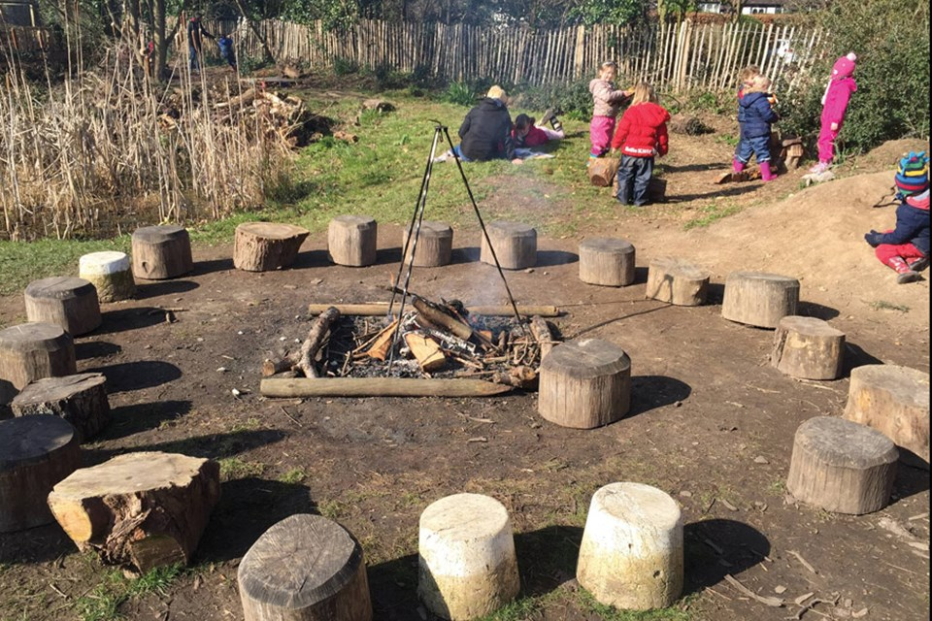 | - Assembly with Mrs Glynn.  - SPORTS DAY on Wednesday.  - Forest school on Friday.  - SCHOOL PHOTO DAY ON TUESDAY.

