Week Beginning: 7th July 2025
This week in Nursery we will be learning…

  Religious Education | - Talking about God the father, God the son and God the holy spirit.
Communication & Language &    Literacy | - Name Writing  - Eye spy, recognising the initial sounds in words.  - ‘n’ sound.  - Reading the story of ‘What the ladybird heard’.  - Drawing the map from our story.
Mathematics & Physical development  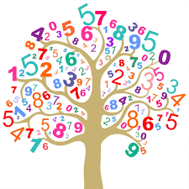 | - Smile for a mile!  - Squiggle while you wriggle!  - Bingo.  - Cutting skills.  - Thinking about weight, talking about heavier, heaviest/lighter, lightest.
Other Areas  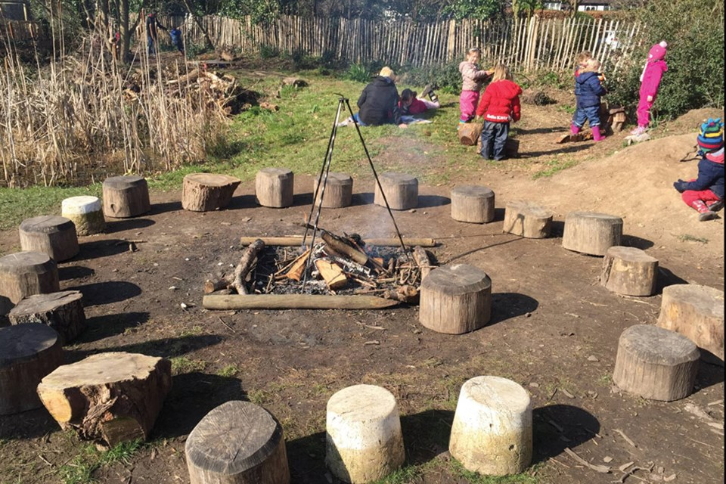 | - Assembly with Mrs Glynn.  - Library on Friday.  - Talking about our Euros country which is Wales.  - Thinking about women in football.  - Painting pictures for our Graduation assembly.

