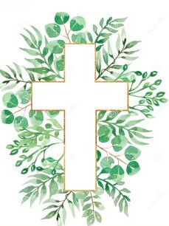
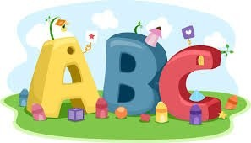
This week in Reception we are learning… W.B. 02.02.26

RE/RSE/PSHE  - We will think about how Jesus welcomed the children.  - Celebration of the word. | Literacy  - In phonics we will learn the special friends igh and ow. We will use our Fred fingers to help us spell words and write simple captions.  - We will play roll and write. We will roll the dice and use the key to find the matching picture and then write the word.  - We will write simple ‘I can see’ sentences.  - Handwriting
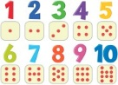  Mathematics  - We will explore the concept more than, fewer and equal to by playing a range of games.  - We will make tally charts of our favourite Nursery rhyme.  - We will look at different amounts and see if we can make them equal. | Understanding the World    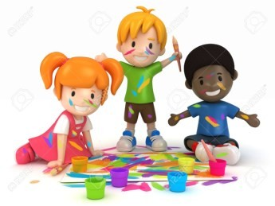  - Through story we will learn about animals that hibernate. We will think about which animals might visit our forest school.
Physical    - Construction  - Smile for a Mile  - Dough/pen disco  - PE with Ross  - Fine motor activities | Expressive Arts and Design  - Making playdoh cakes  - Cutting and sticking

