
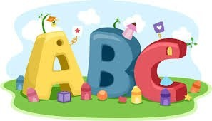
This week in Reception we are learning… W.B. 09.02.26

RE/RSE/PSHE  - We will think about the feeding of the 5000.  - We will act out this miracle.  - Celebration of the word.  - Children’s Mental Health week- we will be thinking about what it means to ‘belong’ we will talk about the places that make us feel like we belong e.g. home, school, friends, sports classes  - Safer Internet Day- Through story we will be thinking about how we can use devices carefully and responsibly. | Literacy  - In phonics we will learn the special friend ‘oo’. We will use our Fred fingers to help us spell words and write simple captions.  - We will read ‘The great nursery rhyme disaster’ and make our own Tales toolkit stories.  - We will practice writing our ‘Red words’.  - We will write simple sentences.  - Handwriting
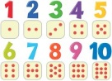  Mathematics  - We will explore the concept of counting out a given number of objects from a large amount. (focusing on the stopping number)  - We will play games to compare who has more or fewer.  - We will make snakes of 3 different lengths and order them from longest to shortest.  - We will play throw and catch with a partner- can we throw and catch the bean bag/ball a given number of times. | Understanding the World    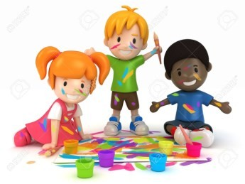  - We will take part in a range of activities to explore the celebrations of Valentine’s day and Pancake day.
Physical    - Construction  - Smile for a Mile  - Dough/pen disco  - PE with Ross  - Fine motor activities | Expressive Arts and Design  - Making playdoh pancakes  - Cut and stick pancakes  - Valentine’s cards

