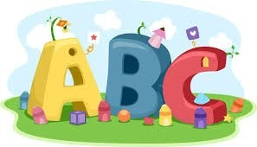This week in Reception we are learning… W.B. 12.05.25

|  |  |
| --- | --- |
| RE/RSE/PSHE   * Assembly with Mrs Glynn * Celebration of the word * Children will hear simple versions of the Pentecost. They will know that Jesus sent his friend- The Holy Spirit to help his friends to spread the word of God. | Literacy   * We will learn new sounds, read and write simple words and sentences in our phonics groups. * Our text this week is ‘Beansprout’ by Sarah Lynne Reul * We will write instructions for planting our seeds. * We will write sentences about a range of pictures. * Handwriting practice |
| Numbers Clipart - Clipart.WorldMathematics   * This week we will continue our learning with the Rekenreks. We will use the Rekenreks to show double amounts and number bonds to 10. * Who has more? We will use objects to explore which character has more? Who has fewer? * We will explore addition by adding spots to ladybird wings. * We will match everyday objects and packaging to 3D shapes. | Earth Clipart Free Earth Clipart Free Globe Earth Green - Planet Earth  Clipart Transparent PNG - 703x720 - Free Download on NicePNGUnderstanding the World   * We will continue to take care of our seeds. We will make sure they have everything they need to grow. We will observe and record any changes to our seeds. * Map making- What the Ladybird heard, map of the farm. |
| Physical   * Construction * Smile for a Mile * Gross and fine motor skill activities * PE with Ross * 42 Handball Girl Illustrations &amp;amp; Clip Art - iStockAthletics with Mrs Wall * Forest school | Expressive Arts and Design   * Music with Mrs Marshall * Painting Minibeasts * Playdough minibeasts * Junk modelling a bug house |