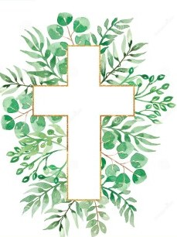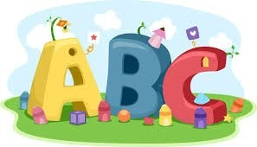This week in Reception we are learning… W.B. 14.10.24

|  |  |
| --- | --- |
| RE/RSE/PSHE   * RE Super learning day- God’s planet   On Monday we will have special visitors at school, they will be helping us to celebrate God’s world. We will take part in a whole school performance about taking care of the planet. We will draw the creation story, make badges, make plastic bag jelly fish, make God’s world and much more. | Literacy   * Our text this week is ‘The girl who loves wellies.’ * In phonics we will learn the sounds and rhymes for the letters- w, x, and z. We will help Fred to read his green words. * We will practice writing our names. * We will sort pictures by matching them to their initial sounds. * We will use our Tales Toolkit bags to retell the story of the girl who loved wellies. We will think about the characters, setting, problem and solution. |
| Mathematics   * We will sing a range of number rhymes and songs. * We will use the Numicon to find how many ways we can make 4. * We will find different ways of making 4 using 2 different coloured cubes. * We will look at comparing amounts. Howard and Teddy are arguing about who has the most toys. Can we help them to find out who has more or fewer toys? How do we know? * Maths of the day- Welly throwing- we will throw wellies and then measure how far we have thrown them using our footsteps.   Numbers Clipart - Clipart.World | Understanding the World  Earth Clipart Free Earth Clipart Free Globe Earth Green - Planet Earth  Clipart Transparent PNG - 703x720 - Free Download on NicePNG   * This week we will explore the ipads. How do we handle them carefully, can we turn them on/off. How do we open an app? How can we stay safe when using the ipads. |
| Physical   * Construction * Smile for a Mile * 42 Handball Girl Illustrations &amp;amp; Clip Art - iStockJump start Johnny * PE with Ross * Forest school | Expressive Arts and Design   * Leaf rubbing * Music * Autumn leaf- handwriting patterns   Clipart Of Children Painting | Free Images at Clker.com - vector clip art  online, royalty free &amp;amp; public domain |