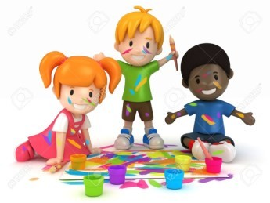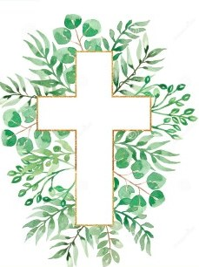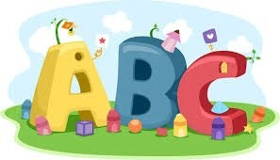This week in Reception we are learning… W.B. 15.09.25

|  |  |
| --- | --- |
| RE/RSE/PSHE   * We will introduce the children to our ‘Golden box’. What do we think is inside? Inside the box will be The Bible. We will discuss with the children that The Bible is a special book. * What is special to us? Children will draw a picture. * We will make loose part crosses. * We will make our own cross using crafts. * We will practice making the sign of the cross in the mirror. | Literacy   * In phonics we will learn the sounds and rhymes for the letters- We will help Fred to read his green words. * We will practice writing our names. * Writing secret messages. * Mark making activities |
| Mathematics   * We will sing a range of number rhymes and songs. * We will learn how to subitise and practice subitizing amounts to 5. * We will practice counting amounts to 5.   Numbers Clipart - Clipart.World | Understanding the World  Earth Clipart Free Earth Clipart Free Globe Earth Green - Planet Earth  Clipart Transparent PNG - 703x720 - Free Download on NicePNG   * We will think about how we are all different and all special. What makes us special? |
| Physical   * Construction * Smile for a Mile * Dough/pen disco * Jump start Johnny * PE with Ross | Expressive Arts and Design   * Drawing * Crafts * Music with Mrs Marshall * We will draw pictures of our family * We will draw a self-portrait. |