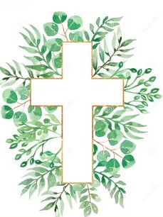
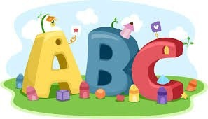
This week in Reception we are learning… W.B. 16.03.26

RE/RSE/PSHE  - We will hear the story of the saddest day.  - We will make cross pictures  - We will look at signs and symbols of Lent.  - We will make loose part crosses. | Literacy  - In phonics we will learn the special friend or. We will use our Fred fingers to help us spell words and write simple captions.  - We will write simple ‘I can see’ sentences about objects we find on a mystery planet.  - We will write captions to match pictures.  - Handwriting
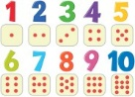  Mathematics  - We will explore the concept of doubling.  - We will make double butterflies  - We will sort dominoes into double/not double  - We will explore doubles using mirrors and Numicon shapes  - We will work with a partner to make double the amount of objects in a shape. (outdoors)  - Weighing moon rocks | Understanding the World    - We will think about how we celebrate Easter. We will discuss our family traditions at Easter.
Physical    - Construction  - Smile for a Mile  - Dough/pen disco  - PE with Ross  - Fine motor activities | Expressive Arts and Design  - Easter Cards  - Balloon planet printing  - Junk modelling rockets

