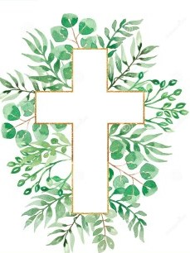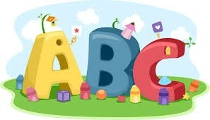This week in Reception we are learning… W.B. 22.09.25

|  |  |
| --- | --- |
| RE/RSE/PSHE   * Inside our golden box will be a picture of the world. Children will explore all of the wonderful things God made for his world. * We will make God’s world with our small world figures. * We will create drawings of the sea and sky. * We will explore light and dark using torches under black material. * We will make sun. moon and star decorations. * We will explore what plants and trees are growing in our outdoor area. | Literacy   * In phonics we will learn the sounds and rhymes for the letters p, o, c- We will help Fred to read his green words. * We will practice writing our names. * Handwriting patterns and letter formation in glitter. * Mark making activities * We will read the story ‘The Friendship Bench’. We will order pictures from the story and retell it in our own words. |
| Mathematics   * We will sing a range of number rhymes and songs. * We will make different arrangements of 3 using pom poms. How many ways can you show 3? * We will sort bears by colour and size. * We will make collections of 3 in egg boxes. * We will practice counting accurately to 5 using sets of objects and a counting stick.   Numbers Clipart - Clipart.World | Understanding the World  Earth Clipart Free Earth Clipart Free Globe Earth Green - Planet Earth  Clipart Transparent PNG - 703x720 - Free Download on NicePNG   * Clipart Of Children Painting | Free Images at Clker.com - vector clip art  online, royalty free &amp;amp; public domain We will think about our senses of sight and hearing. We will go on a senses walk in our outdoor area to see what we can see and hear. |
| Physical  42 Handball Girl Illustrations &amp;amp; Clip Art - iStock   * Construction * Smile for a Mile * Dough/pen disco * Jump start Johnny * PE with Ross * Fine motor activities | Expressive Arts and Design   * Drawing * Crafts * Music with Mrs Marshall * We will paint pictures of things in God’s world. * We will make a paper plate self-portrait. |