
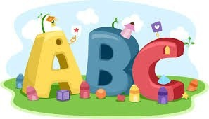
This week in Reception we are learning… W.B. 23.03.26

RE/RSE/PSHE  - We will hear the story of Easter Sunday. We will retell the story using figures.  - We will order the events of Holy Week (cut and stick)  - We will make Easter cards  - We will make Easter gardens.  - We will decorate Easter eggs | Literacy  - In phonics we will write sentences using the sounds we have learnt this half term. (assessment week)  - We will go on a red word Easter egg hunt around the classroom. We will read and write the red words.  - We will write our Easter cards  - Handwriting  - Easter phonics activities
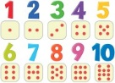  Mathematics  - We will explore the concept of doubling.  - We will make double butterflies using Numicon.  - We will sort objects using different criteria.  - We will explore doubles by doubling amounts on ladybirds.  - We will explore odd and even numbers using the Numberblocks. | Understanding the World    - We will think about how we celebrate Easter. We will discuss our family traditions at Easter.
Physical    - Construction  - Smile for a Mile  - Dough/pen disco  - PE with Ross  - Fine motor activities | Expressive Arts and Design  - Easter Cards  - Easter egg decorating  - Loose part Easter eggs

