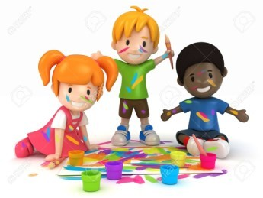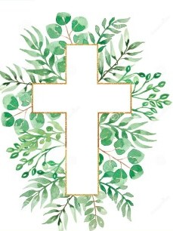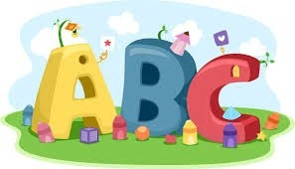This week in Reception we are learning… W.B. 23.09.24

|  |  |
| --- | --- |
| RE/RSE/PSHE   * We will hear the story of Creation. We will think about all the beautiful things God made for his world. * We will build God’s world in our tuff tray. * We will suggest ways we can care for our wonderful world. * Assembly with Mrs Glynn * Prayer and Liturgy- creation | Literacy   * Our text this week is ‘The boy who hated toothbrushes’. * We will mark make on teeth and then use toothbrushes to get them nice and clean. * In phonics we will learn the sounds and rhymes for the letters- p, g, o, c, k We will help Fred to read his green words. * We will practice writing our names. * Mark making activities |
| Mathematics   * We will sing a range of number rhymes and songs. * We will learn how to subitise and practice subitizing amounts to 5. * We will help Howard the maths monkey to accurately count out a set of up to 5 objects. * We will sort our numicon shapes into groups of 1, 2 and 3. * We will make dot patterns of 3. How many ways can we show 3? * We will sort objects by colour.   Numbers Clipart - Clipart.World | Understanding the World  Earth Clipart Free Earth Clipart Free Globe Earth Green - Planet Earth  Clipart Transparent PNG - 703x720 - Free Download on NicePNG   * We will be learning about taking care of our teeth. * On Friday we will have a visit from the dental nurse, who will talk to us about taking good care of our teeth. * We will sort healthy and unhealthy foods for our teeth. |
| Physical   * Construction * Smile for a Mile * Jump start Johnny * PE with Ross | Expressive Arts and Design   * Drawing * Crafts * Music with Mrs Marshall * We will draw pictures of our family * We will paint pictures of God’s world. |