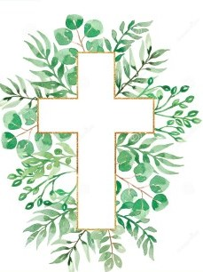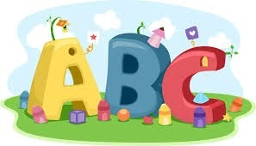This week in Reception we are learning… W.B. 29.09.25

|  |  |
| --- | --- |
| RE/RSE/PSHE   * Inside our golden box will be a picture from the creation story. We will hear the story of Creation from the Bible. * We will think about how we can care for God’s world. * We will draw pictures of the things we need to care for in God’s world. * We will take care of animals in our vet’s roleplay. * We will used recycled materials to make models. * Celebration of the Word: We will hear the story of Noah’s Ark. | Literacy   * In phonics we will learn the sounds and rhymes for the letters k, u, b- We will help Fred to read his green words. * We will practice writing our names. * Handwriting patterns and letter formation in glitter. * Mark making activities * We will read the story ‘The Friendship Bench’. We will draw parts of the story and orally compose a sentence to match the pictures. * We will develop our fine motor skills using scissors. |
| Mathematics   * We will sing a range of number rhymes and songs. * We will make different arrangements of 3 and 4. * We will create repeating patterns using a range of natural objects. * We will have a tea party for 3 teddies. Can we make sure the teddies have just enough for the party. E.g. 3 cups. 3 plates etc.   Numbers Clipart - Clipart.World | Understanding the World  Earth Clipart Free Earth Clipart Free Globe Earth Green - Planet Earth  Clipart Transparent PNG - 703x720 - Free Download on NicePNG   * Clipart Of Children Painting | Free Images at Clker.com - vector clip art  online, royalty free &amp;amp; public domain We will think about our sense of touch. We will explore this by making a texture collage. |
| Physical  42 Handball Girl Illustrations &amp;amp; Clip Art - iStock   * Construction * Smile for a Mile * Dough/pen disco * Forest school * PE with Ross * Fine motor activities | Expressive Arts and Design   * Drawing * Crafts * Music with Mrs Marshall * We will paint pictures of things in God’s world. * We will make a collage. |