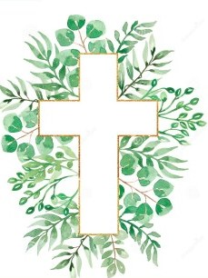
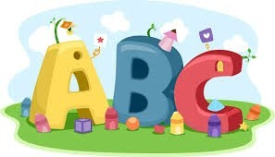
This week in Reception we are learning… W.B. 14.09.26

RE/RSE/PSHE  - Inside our golden box will be a picture of the world. Children will explore all of the wonderful things God made for his world.  . | Literacy  - In phonics we will learn the sounds and rhymes for the letters m, a, d, s  - We will practice forming the letters  - Handwriting patterns and letter formation in glitter.  - Mark making activities  - Recognising and writing our names.
Mathematics  - We will sing a range of number rhymes and songs.  - We will focus on subitising amounts to 3.  - We will make different arrangements of 3 using pom poms. How many ways can you show 3?  - We will sort bears by colour and size.  - We will make collections of 3 in egg boxes.  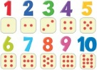 | Understanding the World    - Forest School
Physical    - Construction  - Smile for a Mile  - Dough disco  - Jump start Johnny  - PE with Ross  - Fine motor activities | Expressive Arts and Design  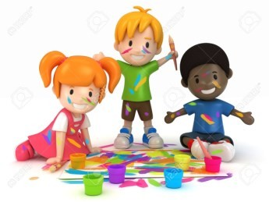  - Self portraits  - Crafts  - We will make a paper plate self-portrait.

