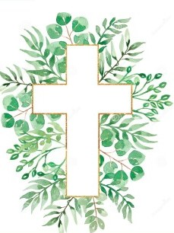
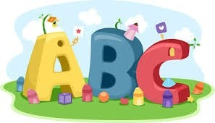
This week in Reception we are learning… W.B. 02.11.26

RE/RSE/PSHE  - We will be learning about Mary and exploring why she was chosen by God to be Jesus’ mother.  - We will draw and paint pictures of Mary.  - We will make collage hearts to show we love God, just like Mary did.  - We will practice saying the Hail Mary. | Literacy  - In phonics we will learn the sounds and rhymes for the letters x,y,z  - We will practice forming the letters  - We will read and write CVC words  - We will write CVC words in glitter using witches brooms.  - Drawing Club- Meg and Mog  - Writing our names.
Mathematics  - We will sing a range of number rhymes and songs.  - We will focus on recognizing and ordering numbers to 5.  - We will match quantities to amounts by building towers using the correct number of cubes to match numbered fireworks.  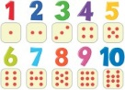  - We will explore how many cups of pasta it will take to fill different sized containers. | Understanding the World    - We will learn about Bonfire night- We will learn about keeping ourselves safe.  - Remembrance Day- We will take part in activities to explore why we celebrate remembrance day.  - We will use Forest school to collect items to match different autumn colours.
Physical    - Construction  - Smile for a Mile  - Dough disco  - Jump start Johnny  - PE with Ross  - Fine motor activities- threading beads onto numbered stars | Expressive Arts and Design  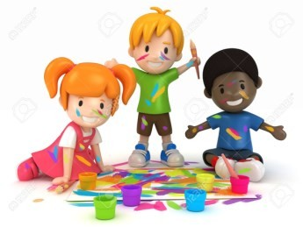  - Pumpkin printing  - Firework printing  - Making poppies

