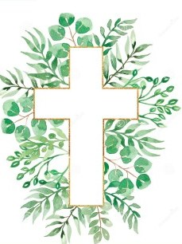
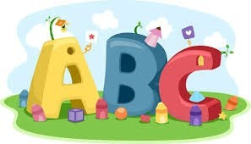
This week in Reception we are learning… W.B. 28.09.26

RE/RSE/PSHE  - Inside our golden box will be a picture of the world. Children will explore all of the wonderful things God made for his world.  . | Literacy  - In phonics we will learn the sounds and rhymes for the letters g, o, c, k  - We will practice forming the letters  - Handwriting patterns and letter formation activities.  - Writing secret codes  - Mark making activities  - Recognising and writing our names.
Mathematics  - We will sing a range of number rhymes and songs.  - We will help 3 teddies get ready for their picnic. We need to make sure there is ‘just enough’ for each teddy.  - We will show different ways of making 3. (sticking dots)  - We will make repeating patterns outside using different coloured cones.  - We will use peg boards to make repeating patterns.  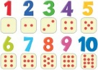 | Understanding the World    - We will learn about our sense of touch. We will use our sense of touch to create our own texture collage using a range of different materials.
Physical    - Construction  - Smile for a Mile  - Dough disco  - Jump start Johnny  - PE with Ross  - Fine motor activities | Expressive Arts and Design  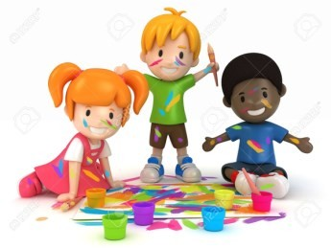  - Paper plate faces  - Junk modelling  - Free painting  - Texture collage

