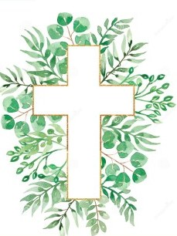
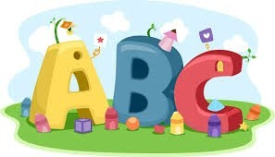
This week in Reception we are learning… W.B. 12.10.26

RE/RSE/PSHE  - This week we will think about how we are all special. God made me and I am special.  - We will discovery a range of activities to explore what makes us special.  . | Literacy  - In phonics we will learn the sounds and rhymes for the letters l, h, r  - We will practice forming the letters  - We will build words using the sounds we have learnt so far.  - We will write the initial sounds in words.  - We will use our ‘Fred fingers’ to identify the sounds in CVC words.  - Recognising and writing our names.
Mathematics  - We will sing a range of number rhymes and songs.  - We will compare amounts using the language of more and fewer. We will work in pairs to collect a handful of small objects we will then use the sentence steam ____has more than____ or _____has fewer than____ to compare our amounts.  - We will use the multilink cubes to make our own Numberblocks 1-5.  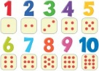  - We will play a team game using hoops and bean bags to compare amounts. | Understanding the World    - We will learn about our sense of smell. We will have a range of pots with hidden smells inside. Children will use their sense of smell to try and identify the smells.
Physical  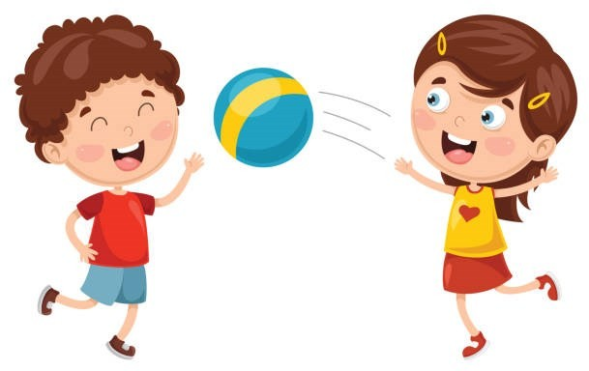  - Construction  - Smile for a Mile  - Dough disco  - Jump start Johnny  - PE with Ross  - Fine motor activities- peg the leaves on the string. | Expressive Arts and Design  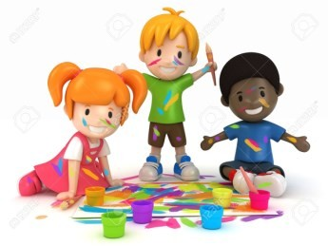  - Leaf rubbing  - Junk modelling  - Painting

